 



Database Programming with SQL 17-3: Regular Expressions Practice Activities

# Objectives

* Describe regular expressions
* Use regular expressions to search, match, and replace strings in SQL statements
* Construct and execute regular expressions and check constraints

# Try It / Solve It

1. Working with the employees table, and using regular expressions, write a query that returns employees whose first names start with a “S” (uppercase) followed by either a “t” (lowercase) or “h” (lowercase).

SELECT * FROM employees

WHERE REGEXP_LIKE(first_name, '^S(t|h)');

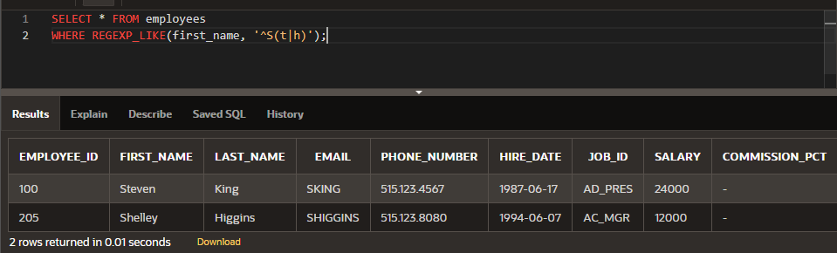

1. Investigate the LOCATIONS table.
   1. Describe the table.

DESCRIBE locations;

SELECT constraint_name, constraint_type, r_constraint_name FROM user_constraints WHERE table_name = 'LOCATIONS';

SELECT constraint_name, constraint_type, table_name FROM user_constraints WHERE r_constraint_name = (SELECT constraint_name FROM user_constraints WHERE table_name = 'LOCATIONS' AND constraint_type = 'P');

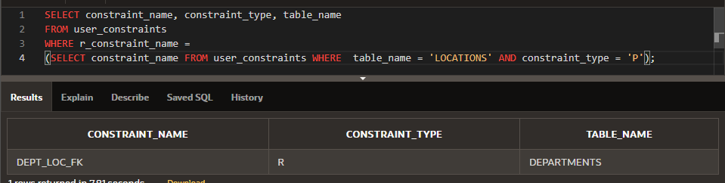

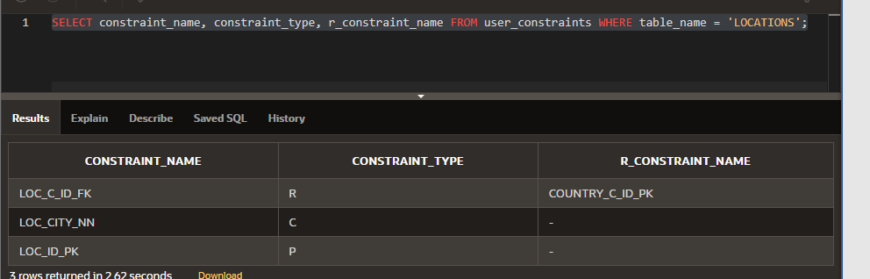

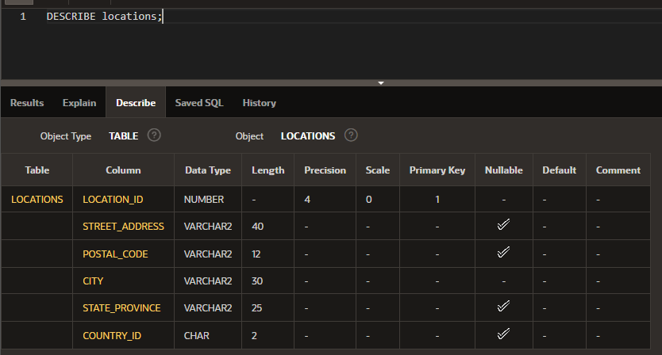

* 1. Perform a select that returns all rows and all columns of that table.

SELECT * FROM locations;

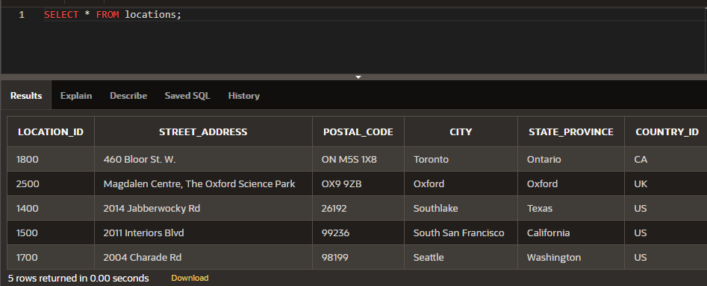

* 1. Write a query using regular expressions that removes the spaces in the street_address column in the LOCATIONS table.

SELECT street_address, REGEXP_REPLACE(street_address, ' ','') street_address_changed

FROM locations;

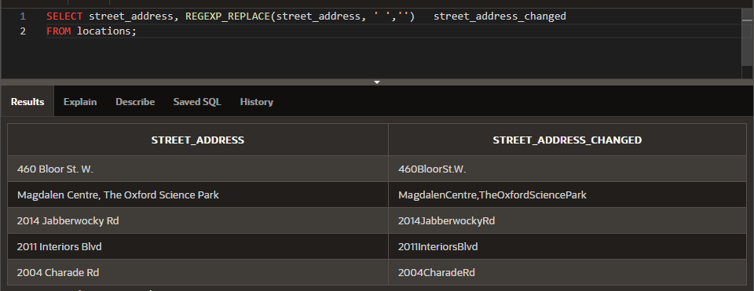

Copyright © 2020, Oracle and/or its affiliates. All rights reserved. Oracle and Java are registered trademarks of Oracle and/or its affiliates. Other names may be trademarks of their respective owners.